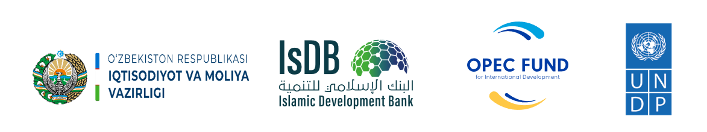

Islamic Development Bank
Ministry of Economy and Finance of the Republic of Uzbekistan
United Nations Development Programme in Uzbekistan

Project Title: | IsDB Integrated Rural Development Project Component B: Consultancy services for rural infrastructure development – Community empowerment.
Country: | Uzbekistan
Contract Number: | Agreement for delivery outputs
Implementation period: | 13 May 2024 – 31 December 2028 (56 months)
PROJECT NARRATIVE REPORT

Reporting period: | January 1 – December 31, 2024
Report prepared by: | UNDP CO Uzbekistan

Tashkent 2024

TABLE OF CONTENTS

TABLE OF CONTENTS 2
ABBREVIATIONS & ACRONYMS 3
TITLE LIST 4
SECTION 1. OVERALL INFORMATION 5
EXECUTIVE SUMMARY 7
SECTION 2. DESCRIPTION AND SUMMARY OF ANNUAL PROGRESS AND RESULTS 9
PROJECT IMPLEMENTATION PROGRESS 9
PROGRESS OF ACTIVITY 1. 9
PROGRESS OF ACTIVITY 2: 19
PROGRESS OF ACTIVITY 4: 21

ABBREVIATIONS & ACRONYMS

APA | Annual Plan of Activities
AWP | Annual Work Plan
BOA | Budget of Action
BPR | Business Process Re-engineering
CDP  CDR | Community Development Plan  Combined Delivery Report
CO | Country Office
ECA | Ecologic and Climate Action Cluster
GOU  IA | Government Operations Unit  Implementing Agency
IsDB  LDP  LoA | Islamic Development Bank  Local Development Plan  Letter of Agreement
M&E | Monitoring and Evaluation
NIM | National Implementation Modality
NPC | National Project Coordinator
MEF | Ministry of Economy and Finance
OPEC Fund  PIR  PIU | OPEC Fund for International Development  Project Implementation review  Project Implementation Unit
PM | Project Manager
POPP | Programme and Operations Policies and Procedures
QMS  RBM | Quality Management System  Results-Based Management
RIA | Regulatory Impact Assessment
SDG | Sustainable Development Goals
TOR  TOT  TWG | Terms of Reference  Training for Trainers  Technical Working Group
UNDP | United Nations Development Programme
USD | United States Dollar
WB | World Bank

TITLE LIST
Project number and title: | 01002383  IsDB Sustainable Rural Development Project Component B: Engineering Services and Strengthening Capacity in Infrastructure Management
Project Starting date: | 13 May 2024
Project completion date: | 31 December 2028
Implementing Partner: | Ministry of Economy and Finance of the Republic of Uzbekistan
Donor (s): | Islamic Development Bank & OPEC Fund for International Development
Contract # | Agreement to delivery output between

Total Budget for entire project period | Original Budget (USD) | Latest Signed Revision (USD)
Total Budget for entire project period | 6,000,000.00 | 6,000,000.00

Resources | Donor | Amount (USD)
Resources | Islamic Development Bank | 6,000,000.00
Resources | Government  (Parallel or cost-sharing) | N/A

Period covered by this report: | 01.01.2024 – 31.12.2024
Date of annual review (Project Board meeting): | 10.12.2024

Budget for reporting period (as per the Annex III – the Budget for the Action) | Budget (USD)  (01.01.2024 – 31.12.2024) | Expenditure till  31 December 2024 (USD)
 | 742,399.45 | 616,673.07

SECTION 1. OVERALL INFORMATION
PROJECT SYNOPSIS
Project title | IsDB Integrated Rural Development Project Component B: Consultancy services for rural infrastructure development – Community empowerment.
Project number | 01002385
Country | Republic of Uzbekistan
Overall objective | This UNDP Project is an integral component of the broader Uzbekistan - Integrated Rural Development Project financed by the Islamic Development Bank (IsDB) and executed by the Ministry of Economy and Finance. The overall objective of UNDP Project is to empower and build capacities of local partners (communities, architects, engineers, local authorities) in developing and implementing local development plans and promoting locally relevant green and energy efficient. "UNDP Component B: Consultancy services for rural infrastructure development - Community empowerment, Phase II" project aims to raise the living standards, build capacity, and improve the prosperity of the rural population in three targeted regions. The Project aims to build capacities of targeted communities and partners in adopting and implementing environmentally friendly solutions. The Project will also confer positive impacts on human development through increased economic opportunities and wellbeing of targeted communities. Climate-related concerns will be mainstreamed into decision-making at all levels, facilitating climate-resilient and energy efficient development from the community level up to the regional level. The project takes a people-centred, gender sensitive and climate risk-informed holistic approach. The IRD Project is targeting Samarkand, Kashkadarya and Surkhandarya regions where poverty rates are high, with 157 mahallas where infrastructure development are lagging to be supported.
Outcome | Number of innovative and scalable solutions applied through systems integration in the three pilot regions
Outputs | Output 1: Development and implementation of Community Development Plans (CDPs). Strengthened capacities of 157 mahallas in Samarkand, Kashkadarya, and Surkhandarya regions in participatory CDP process that result in development, implementation, and oversight of climate smart CDPs focusing on improvements of infrastructure and services.  Output 2: Capacity building in income generation, with focus on vulnerable groups. Strengthened capacities of businesses and individuals such as entrepreneurs who work in agriculture complex, including the vulnerable groups in businesses development/expansion.  Output 3: Capacity building of regional and local authorities. Strengthened capacities of officials in all targeted regional and local authorities in participatory planning, implementation, oversight, and sustainable management of the local infrastructure and services. 2. Strengthened capacities of local residents, including the vulnerable groups in participatory decision making.  Output 4: Project Management
Activities | Output 1: (1.1) Identification of 157 villages in 3 regions through in-depth vulnerability assessment and participatory prioritization exercise to focus on villages with high poverty rates and underdeveloped infrastructure; (1.2) Establishment of the platform for CDPs development and implementation enabling access of local people. Capacity building of community leaders, CSOs, women, youth, persons with disabilities to engage into community CDPs development, implementation, and oversight; (1.3)Participatory needs assessments of target communities, based on experiences of IsDB, UNDP and WB; (1.4) Development of costed options for community infrastructural investments. Identification of preferred options through community engagement, using innovative ICT solutions; (1.5) Support IsDB PMU in implementation of infrastructure components of CDPs;  Output 2: (2.1) Regional market diagnostics/assessment of local business capacitiesRegional market diagnostics/assessment of local business capacitiesRegional market diagnostics/assessment of local business capacitiesRegional market diagnostics/assessment of local business capacities; (2.2) Design and delivery of targeted training on rural business development, with primary focus on the poor, women who are heads of households, youth, and persons with disabilities. Training topics will be informed by regional market diagnostics. Vulnerable beneficiaries to be identified by communities. Trainings can be delivered in partnership with CSOs; (2.3) Training of selected smallholder farmers on climate-smart solutions to increase agricultural productivity and inclusion into the value chain (e.g., water harvesting, drip irrigation, marketing) and crops diversification (e.g., fruit and nut trees); (2.4) Hands-on follow up technical support of farmers, businesses and individuals on inputs and technologies, sales, and marketing; (2.5) Identification and promotion of locally relevant climate smart and energy efficient business solutions;  Output 3: (3.1) Functional review of local authorities and communities (selected); (3.2)Training of district khokimiyats and mahalla committees, initiative groups in participatory planning, implementation, and M&E with a focus on women, youth, and vulnerable groups; (3.3) Training of district khokimiyats and mahalla committees and initiative groups on climate change adaptation and mitigation; (3.4) Implementation of participatory ICT solutions in integrated rural development planning, accountability, and sustainable management of infrastructure; (3.5) Training of local CSOs, women and vulnerable groups on effective engagement into regional and local decision-making. Some trainings can be delivered by CSOs; (3.6) Training of district khokimiyats and mahalla committees, initiative groups on maintenance schemes for all infrastructure and services created through CDPs, fostering environmentally and socially responsible approaches based on low costs and participatory approaches; (3.7) Systematic identification of effective practices in integrated rural development and advocacy on their scale-up regionally and nationally;  Output 4: (4.1) Overall management and coordination of Project implementation; (4.2) Strategic technical and methodological guidance to regional implementation Units; (4.3) Final endorsement of community projects for grant award (CDPs); (4.4) Monitoring of implementation of project activities; (4.5) Provide inputs to ECA Cluster on communication and reporting to MoEF and IsDB
Target groups | - Population in targeted rural areas, particularly women, youth, elderly, people with disabilities  - Civil servants of government organizations and private sector who work in rural areas (doctors, architectures, farmers, teachers, designers, and others)
Project starting date | 13 May 2024
Project duration | 13 May 2024 – 31 December 2028 (56 months)

EXECUTIVE SUMMARY
Uzbekistan joined the Islamic Development Bank (IsDB) in 2003 year. Uzbekistan is a landlocked country strategically located in the heart of Central Asia, bordering Kazakhstan, Tajikistan, Kyrgyz Republic, Turkmenistan, and Afghanistan. It is a lower middle-income country and rich with mineral resources. With 35 million populations (2022), Uzbekistan accounts for about 45% of the Central Asian region's total population, whereas about half of population of Uzbekistan live in rural area. It has a territory of 448.9 thousand km².
The IsDB Integrated Rural Development project – “The UNDP Component B: Consultancy services for rural infrastructure development - Community empowerment, Phase II (Project) - is a timely support to the Government’s reform agenda to mprove standards of living for the rural population in targeted areas.
The project has three major objectives. The first one is to develop and implement Community Development Plans and by this capacities of 157 mahallas in Samarkand, Kashkadarya, and Surkhandarya regions in participatory CDP process that result in development, implementation, and oversight of climate smart CDPs focusing on improvements of infrastructure and services.
The second objective is to build capacities of in income generation, with focus on vulnerable groups and strengthen capacities of businesses and individuals such as entrepreneurs who work in agriculture complex, including the vulnerable groups in businesses development/expansion.
The third objective is to build the capacities of regional and local authorities and strengthen capacities of officials in all targeted regional and local authorities in participatory planning, implementation, oversight, and sustainable management of the local infrastructure and services. To achieve main outcome and major objectives, the project has been implemented by three pillars/components and one supportive component/pillar:
Output 1: Development and implementation of Community Development Plans (CDPs). Strengthened capacities of 157 mahallas in Samarkand, Kashkadarya, and Surkhandarya regions in participatory CDP process that result in development, implementation, and oversight of climate smart CDPs focusing on improvements of infrastructure and services.
Output 2: Capacity building in income generation, with focus on vulnerable groups. Strengthened capacities of businesses and individuals such as entrepreneurs who work in agriculture complex, including the vulnerable groups in businesses development/expansion.
Output 3: Capacity building of regional and local authorities. Strengthened capacities of officials in all targeted regional and local authorities in participatory planning, implementation, oversight, and sustainable management of the local infrastructure and services. 2. Strengthened capacities of local residents, including the vulnerable groups in participatory decision-making.
Component 4: Project management
The project will find solutions for the key barriers to sustainable environmentally friendly and energy efficient development and digital solutions in rural areas supporting human development. Here are as major challenges and barriers work for:
- Insufficient knowledge base, information, and communication on the environmentally friendly, gender-sensitive, energy efficient and digital rural areas-tailored solutions in the areas of architecture, social infrastructure, and community development.
- Limited capacities and incentives for local authorities to identify, develop and implement the environmentally friendly, gender-sensitive, energy efficient and digital rural solutions in the areas of architecture, social infrastructure, and community development.
- Limited opportunities and capacities of communities to develop plans of local development.
- Lack of gender and age disaggregated data.
The project implementation has started officially on May 13, 2024 with the annual approved budget of USD 1,060,684.53 for 2024, where the IsDB is the main donor of the project. Project is operational in 3 pilot regions of Uzbekistan: Samarkand, Surkhandarya, and Kashkadarya regions.
In the reporting period, UNDP worked jointly with the PIU under the Ministry of Economy and Finance in the selected 157 communities located in 21 districts of Samarkand, Surkhandarya, and Kashkadarya regions by implementing activities of all three components.
In 2024, the project focused on selecting 157 pilot communities and identifying the socio-economic needs of each one. Presentations about the project were organized in the regional hokimiyats of three pilot regions. Eight local facilitators and two engineers were trained in community mobilization workshops and the development of Community Development Plans (CDPs). Participants learned skills in community needs assessment, facilitation methods, planning, evaluation, and the structure and verification processes of CDP development. Community mobilization workshops were conducted in all 157 communities, reaching a total of 11,000 people, including 6,587 males and 4,413 females. Additionally, Initiative Group members were selected, totaling 1,126 individuals. Among them, 345 were females (31%), 303 were pensioners, and 15 were people with disabilities. Also, during the report period the project focused its activities on visual and technical verifications of the subprojects and verified more than 750 sites in 157 communities.
Specifically, project activities included the followings:
- Recruitment of 9 local facilitators and 2 temporary engineers with relevant competencies in 4 regions.
- ToT trainings on community mobilization & CDP development for UNDP & PIU staff and local facilitators organized by involving national consultants
- Visual and technical verification of more than 900 sites and selection of 780 construction subprojects in three pilot regions
- Study tour to Korea and Vietnam to see best practices of rural development, digitalization, energy and water efficiency projects, CDP and other best practices conducted on November 19-29, 2024 for representatives of Ministry of Economy and Finance, pilot khokimiyats, PIU and UNDP.
Besides, project initiated and conducted several other activities during the reporting period. Specifically:
- Initiate the process of Baseline assessment in 41 pilot communities for assessing the living conditions, employment opportunities, and social well-being of people in rural areas of Uzbekistan, as well as the impact of climate change.
- Validation assessment of 157 communities of three pilot regions.
In 2024, the project developed and placed more than 100 publications in social media resources (Facebook, LinkedIn, Twitter, Instagram, and Telegram) including national and international mass media, up to 50 press releases, video, and animated videos, infographics and posters and other visibility materials.
In the project management and operations part, during the reporting period, the project finalized the recruitment process of all 21 personnel, 3 project offices for UNDP and PIU established and furnished, procured 3 new project cars. The project launch event was held in October. The first Project Board Meeting organized in December to which the representatives of national ministries, agencies, institutions, and regional authorities of Karakalpakstan, Khorezm, Bukhara and Navoi regions, IsDB, UNDP, IFIs, and Development Partners were invited. During the meeting, the project progress for 2024 and plans for 2025 were presented and discussed.

SECTION 2. DESCRIPTION AND SUMMARY OF ANNUAL PROGRESS AND RESULTS

PROJECT IMPLEMENTATION PROGRESS

PROGRESS OF ACTIVITY 1.
Development and implementation of Community Development Plans (CDPs). Outputs: Strengthened capacities of 157 mahallas in Samarkand, Kashkadarya, and Surkhandarya regions in participatory CDP process that result in development, implementation and oversight of climate smart CDPs focusing on improvements of infrastructure and services.
Activity 1.1 Identification of 157 villages in 3 regions through in-depth gender-sensitive vulnerability assessment and participatory prioritization exercise to focus on villages with high poverty rates and underdeveloped infrastructure.
Progress:
- Project discussions conducted in three pilot regions khokimiats on the final selection of 157 communities
- Project introduction presentations conducted in three pilot regions (3 regional authorities, 21 districts, and 157 communities

Photos of project presentations:
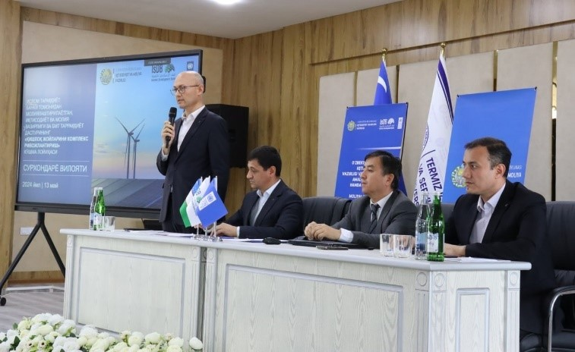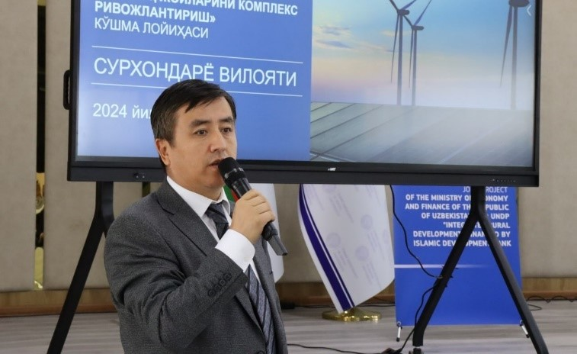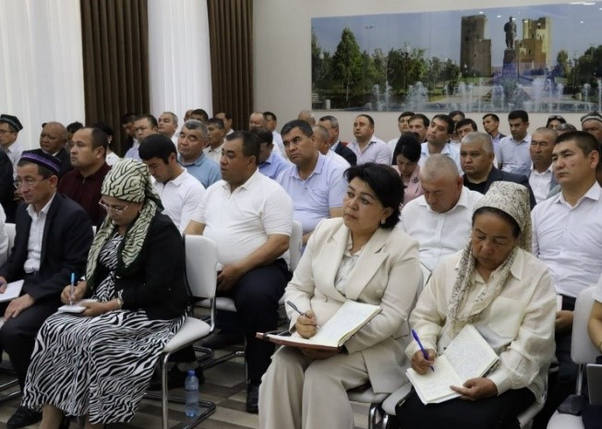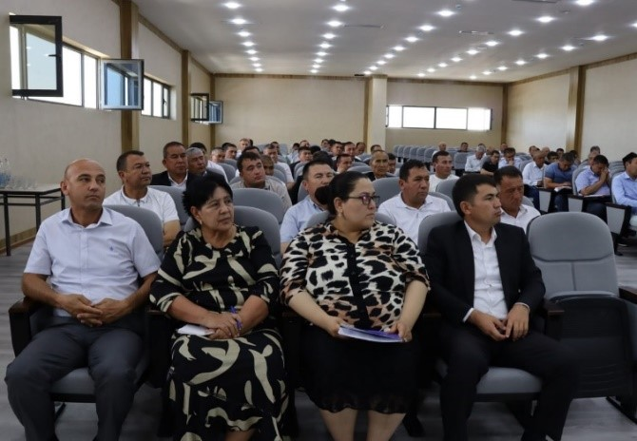
Output:
- 157 communities identified by the Ministry of Economy and Finance and regional khokimiats
- Regional and district authorities, selected communities, regional departments of line ministries, and mass media of Surkhandarya, Kashkadarya, and Samarkand regions increased awareness about project implementation activities for 2024 – 2028:
- Surkhandarya region - 5 districts, 60 communities
- Samarkand region - 10 districts, 52 communities
- Kashkadarya region - 6 districts, 45 communities
LIST OF SELECTED 157 PILOT COMMUNITIES:
# | Region | District | Community
1. | Surkhandarya region | Boysun district | MCC Temir Darvoza
2. | Surkhandarya region | Boysun district | MCC Shifo buloq
3. | Surkhandarya region | Boysun district | MCC Darband
4. | Surkhandarya region | Boysun district | MCC Urta Machay
5. | Surkhandarya region | Boysun district | MCC Dahnayjon
6. | Surkhandarya region | Boysun district | MCC Dashtigoz
7. | Surkhandarya region | Boysun district | MCC Kovrun
8. | Surkhandarya region | Boysun district | MCC Bibishirin
9. | Surkhandarya region | Boysun district | MCC Pulhokim
10. | Surkhandarya region | Sherobod district | MCC Gurjak-2
11. | Surkhandarya region | Sherobod district | MCC Uzunsoy
12. | Surkhandarya region | Sherobod district | MCC Guliston
13. | Surkhandarya region | Sherobod district | MCC Kizilolma
14. | Surkhandarya region | Sherobod district | MCC Korabog
15. | Surkhandarya region | Sherobod district | MCC Zarabog
16. | Surkhandarya region | Sherobod district | MCC Chorbog
17. | Surkhandarya region | Sherobod district | MCC Nurtepa
18. | Surkhandarya region | Sherobod district | MCC Hojakiya-2
19. | Surkhandarya region | Sherobod district | MCC Chukurkol
20. | Surkhandarya region | Sherobod district | MCC Chomishli
21. | Surkhandarya region | Sherobod district | MCC Mehnatobod
22. | Surkhandarya region | Sherobod district | MCC Dostlik
23. | Surkhandarya region | Sherobod district | MCC Oktepa
24. | Surkhandarya region | Sherobod district | MCC Istiqbol
25. | Surkhandarya region | Sherobod district | MCC Kulluksho
26. | Surkhandarya region | Sherobod district | MCC Mehrobod
27. | Surkhandarya region | Sherobod district | MCC Gurjak-1
28. | Surkhandarya region | Sherobod district | MCC Hakimobod
29. | Surkhandarya region | Sherobod district | MCC Navbur
30. | Surkhandarya region | Sherobod district | MCC Gorin-Gilambob
31. | Surkhandarya region | Sherobod district | MCC Boybulok
32. | Surkhandarya region | Angor district | MCC Gilambob
33. | Surkhandarya region | Angor district | MCC Homkon
34. | Surkhandarya region | Angor district | MCC Guliston
35. | Surkhandarya region | Angor district | MCC Yukori Talashon
36. | Surkhandarya region | Angor district | MCC Dostlik
37. | Surkhandarya region | Angor district | MCC Novshahar
38. | Surkhandarya region | Angor district | MCC Chinobod
39. | Surkhandarya region | Angor district | MCC Karvon
40. | Surkhandarya region | Angor district | MCC Korabog
41. | Surkhandarya region | Muzrabot district | MCC Fayziobod
42. | Surkhandarya region | Muzrabot district | MCC Chegarachi
43. | Surkhandarya region | Muzrabot district | MCC Guliston
44. | Surkhandarya region | Muzrabot district | MCC Halq Yoli
45. | Surkhandarya region | Muzrabot district | MCC Sopollitepa
46. | Surkhandarya region | Muzrabot district | MCC Mehrigiyoh
47. | Surkhandarya region | Muzrabot district | MCC Alpomish
48. | Surkhandarya region | Muzrabot district | MCC Olmazor
49. | Surkhandarya region | Muzrabot district | MCC Mehnatobod
50. | Surkhandarya region | Muzrabot district | MCC Darband
51. | Surkhandarya region | Muzrabot district | MCC Yangiyer
52. | Surkhandarya region | Muzrabot district | MCC Nurli Hayot
53. | Surkhandarya region | Muzrabot district | MCC Fidokor
54. | Surkhandarya region | Muzrabot district | MCC Buyuk Ipak Yoli
55. | Surkhandarya region | Muzrabot district | MCC Madaniyat
56. | Surkhandarya region | Termez district | MCC Yangiobod
57. | Surkhandarya region | Termez district | MCC At-Termiziy
58. | Surkhandarya region | Termez district | MCC Nurafshon
59. | Surkhandarya region | Termez district | MCC Orol
60. | Surkhandarya region | Termez district | MCC Yangihayot
61. | Kashkadarya region | Kitob district | MCC Samarkand
62. | Kashkadarya region | Kitob district | MCC Kaynar
63. | Kashkadarya region | Kitob district | MCC Sharq Yulduzi
64. | Kashkadarya region | Kitob district | MCC Istikbol
65. | Kashkadarya region | Kitob district | MCC Yangi Zamon
66. | Kashkadarya region | Kitob district | MCC Charmgar
67. | Kashkadarya region | Kitob district | MCC Bogbon
68. | Kashkadarya region | Kitob district | MCC Pahtaobod
69. | Kashkadarya region | Shahrizabz district | MCC Ravot
70. | Kashkadarya region | Shahrizabz district | MCC Oqdaryo
71. | Kashkadarya region | Shahrizabz district | MCC Hojahurson
72. | Kashkadarya region | Shahrizabz district | MCC Loliston
73. | Kashkadarya region | Shahrizabz district | MCC Hontepa
74. | Kashkadarya region | Shahrizabz district | MCC Yangiqishloq
75. | Kashkadarya region | Yakkabog district | MCC Mevazor
76. | Kashkadarya region | Yakkabog district | MCC Koshchinor
77. | Kashkadarya region | Yakkabog district | MCC Alakuylak
78. | Kashkadarya region | Yakkabog district | MCC Istiqlol
79. | Kashkadarya region | Yakkabog district | MCC Istiqbol
80. | Kashkadarya region | Yakkabog district | MCC Yashnobod
81. | Kashkadarya region | Yakkabog district | MCC Chimkorgon
82. | Kashkadarya region | Yakkabog district | MCC Uchtepa
83. | Kashkadarya region | Yakkabog district | MCC Navruz
84. | Kashkadarya region | Guzor district | MCC Halqobod
85. | Kashkadarya region | Guzor district | MCC Yangiobod
86. | Kashkadarya region | Guzor district | MCC Muminobod
87. | Kashkadarya region | Guzor district | MCC Boston
88. | Kashkadarya region | Guzor district | MCC Humdon
89. | Kashkadarya region | Guzor district | MCC Chanoq
90. | Kashkadarya region | Guzor district | MCC Amir Temur
91. | Kashkadarya region | Dekhonobod district | MCC Uzbekiston
92. | Kashkadarya region | Dekhonobod district | MCC Pahtachi
93. | Kashkadarya region | Dekhonobod district | MCC Dehkonobod
94. | Kashkadarya region | Dekhonobod district | MCC Boston
95. | Kashkadarya region | Dekhonobod district | MCC Oydin Yol
96. | Kashkadarya region | Dekhonobod district | MCC Yashnobod
97. | Kashkadarya region | Kamashi district | MCC Kiziltepa
98. | Kashkadarya region | Kamashi district | MCC Tinchlik
99. | Kashkadarya region | Kamashi district | MCC Boburtepa
100. | Kashkadarya region | Kamashi district | MCC Elabod
101. | Kashkadarya region | Kamashi district | MCC Bunyodkor
102. | Kashkadarya region | Kamashi district | MCC Qishliq
103. | Kashkadarya region | Kamashi district | MCC Yuksalish
104. | Kashkadarya region | Kamashi district | MCC Oynakul
105. | Kashkadarya region | Kamashi district | MCC Istikbol
106. | Samarkand region | Bulungur district | MCC Olmazor
107. | Samarkand region | Bulungur district | MCC Fozil Yoldosh
108. | Samarkand region | Bulungur district | MCC Yangiarik
109. | Samarkand region | Bulungur district | MCC Yangiobod
110. | Samarkand region | Jomboy district | MCC Dekhonobod
111. | Samarkand region | Jomboy district | MCC Suhmon
112. | Samarkand region | Jomboy district | MCC Nazar
113. | Samarkand region | Jomboy district | MCC Beshbola
114. | Samarkand region | Jomboy district | MCC Koramuyin
115. | Samarkand region | Ishtihon district | MCC Azamat
116. | Samarkand region | Ishtihon district | MCC Kirkyigit
117. | Samarkand region | Ishtihon district | MCC Dekhonobod
118. | Samarkand region | Ishtihon district | MCC Humo
119. | Samarkand region | Ishtihon district | MCC Besharik
120. | Samarkand region | Ishtihon district | MCC Murodobod
121. | Samarkand region | Kattakurgon district | MCC Polvontepa
122. | Samarkand region | Kattakurgon district | MCC Koradaryo
123. | Samarkand region | Kattakurgon district | MCC Balandravot
124. | Samarkand region | Kattakurgon district | MCC Olmazor
125. | Samarkand region | Kattakurgon district | MCC Uyshun
126. | Samarkand region | Kattakurgon district | MCC Navbahor
127. | Samarkand region | Narpay district | MCC Sarbozor
128. | Samarkand region | Narpay district | MCC Turon
129. | Samarkand region | Narpay district | MCC Nogarahona
130. | Samarkand region | Narpay district | MCC Istiqlol
131. | Samarkand region | Narpay district | MCC Navruz
132. | Samarkand region | Okdaryo district | MCC Okdaryo
133. | Samarkand region | Okdaryo district | MCC Kumushkent
134. | Samarkand region | Okdaryo district | MCC Yangiobod
135. | Samarkand region | Okdaryo district | MCC Temirsak
136. | Samarkand region | Pahtachi district | MCC Saroy
137. | Samarkand region | Pahtachi district | MCC Mirzo Olim
138. | Samarkand region | Pahtachi district | MCC Sardoba
139. | Samarkand region | Pahtachi district | MCC Amirobod
140. | Samarkand region | Samarkand district | MCC Shurboyi
141. | Samarkand region | Samarkand district | MCC Shurboyicha
142. | Samarkand region | Samarkand district | MCC Yangiariq
143. | Samarkand region | Samarkand district | MCC Bozi
144. | Samarkand region | Samarkand district | MCC Kushtamgali
145. | Samarkand region | Samarkand district | MCC Chumchukli
146. | Samarkand region | Tayloq district | MCC Madaniyat
147. | Samarkand region | Tayloq district | MCC Vorsin
148. | Samarkand region | Tayloq district | MCC Honchorbog
149. | Samarkand region | Tayloq district | MCC Muborak
150. | Samarkand region | Urgut district | MCC Kenagas
151. | Samarkand region | Urgut district | MCC Korabuloq
152. | Samarkand region | Urgut district | MCC Bahrin
153. | Samarkand region | Urgut district | MCC Beshkon
154. | Samarkand region | Urgut district | MCC Jartepa
155. | Samarkand region | Urgut district | MCC Boybul
156. | Samarkand region | Urgut district | MCC Zarafshon
157. | Samarkand region | Urgut district | MCC Rahmatobod

Activity 1.2 Establishment of the platform for CDPs development and implementation enabling access of local people. Capacity building of community leaders, CSOs, young women, youth, persons with disabilities to engage into community CDPs development, implementation, and oversight.
Progress:
- ToT training conducted for local facilitators, PIU and UNDP project staff from Kashkadarya, Surkhandarya and Samarkand regions on March 27-29, 2024 in Karshi city
- ToT Training conducted for local facilitators, PIU and UNDP project staff on September 4-6, 2024 in Samarkand
- Community Initiative Groups were selected by rural population in three pilot regions. There were selected 1,126 people (407 pensioners), including 781 males and 345 females.

Figure 1. Gender-disaggregated data
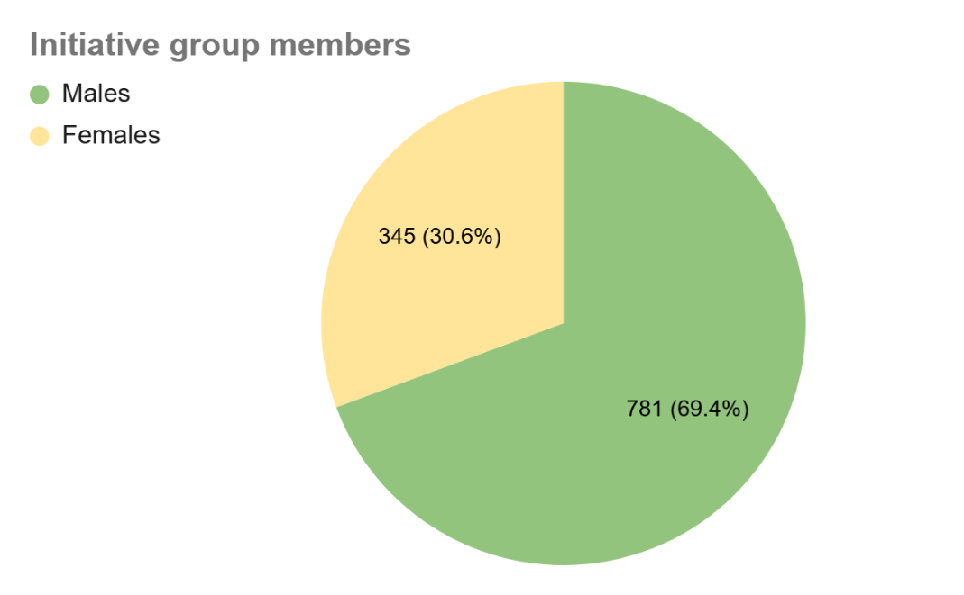
Output:
- 25 local facilitators, PIU and UNDP staff members trained in ToT training in Karshi regarding conducting community mobilization workshops and CDP development.
25 participants local facilitators, UNDP, and PIU staff members in ToT training in Samarkand regarding conducting community mobilization workshops and CDP development.
1.3 Participatory needs assessments of target communities, based on experiences of IsDB, UNDP, and WB.
Progress:
- Community mobilization workshops conducted in 157 communities in three pilot regions
- SWOT analysis, visual and technical verifications conducted to identify and finalize the list of subprojects
Figure 2.
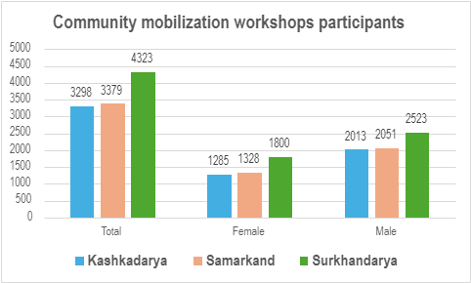
Figure 3. Gender-disaggregated data
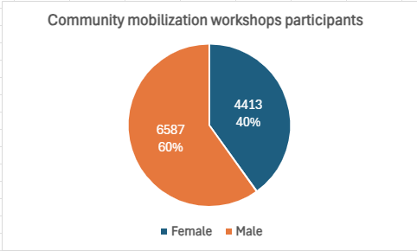
Outputs:
- Mobilization workshops in 157 communities of Samarkand, Kashkadarya and Surkhandarya regions:
- 60 communities in Surkhandarya region
- 45 communities in Kashkadarya region
- 52 communities in Samarkand region
- 11,000 community members including 6587 males and 4413 females trained in community mobilization workshops:
- 4323 people trained in Surkhandarya region including 2523 males and 1800 females
- 3298 people trained in Kashkadarya region including 2013 males and 1285 females
- 3379 people trained in Samarkand region including 2051 males and 1328 females.

- SWOT analysis completed in 157 communities in three pilot regions:
- Samarkand region – 10 district, 52 communities
- Kashkadarya region – 6 districts, 45 communities
- Surkhandarya region – 5 districts, 60 communities
- Visual and technical verifications of almost 900 subprojects completed and 780 subprojects selected (see Annex 2)
- Samarkand region – 10 district, 52 communities, 281 subprojects
- Kashkadarya region – 6 districts, 45 communities, 235 subprojects
- Surkhandarya region – 5 districts, 60 communities, 264 subprojects
Figure 4.
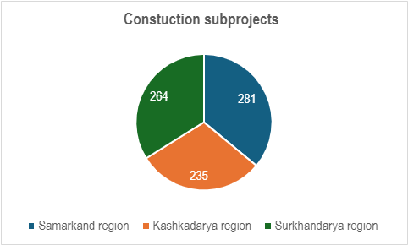
Figure 5.

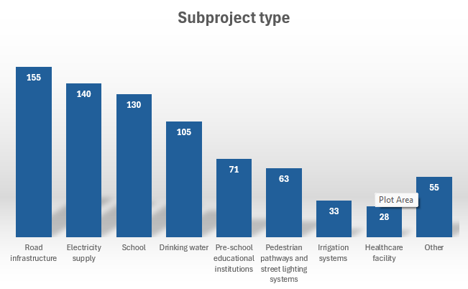

Activity 1.4 Development of costed options for community infrastructural investments. Identification of preferred options through community engagement, using innovative ICT solutions. Development of CDPs.
Progress:
- Project technical alignment discussions conducted in three pilot regions khokimiayts on final selection of subprojects for 157 communities. As a result, 780 subprojects identified for further processing with local authorities
- Study tour to Korea and Vietnam to see best practices of rural development, digitalization, energy and water efficiency projects, CDP and other best practices conducted on November 19-29, 2024
Photos of study tour to Korea and Vietnam:
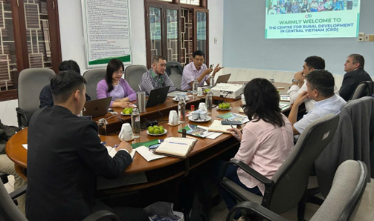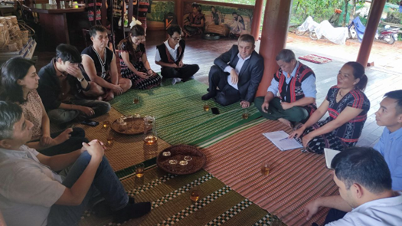
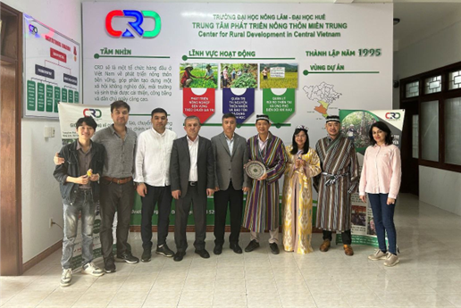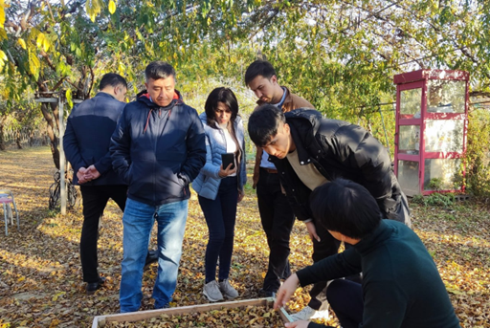
Output: N/A
Activity 1.5 Support IsDB PIU in the implementation of infrastructure components of CDPs.
Progress:
      - Development of Cluster CDPs for the 157 selected communities: Draft version of Cluster CDPs initiated on verified sub-projects chosen by 77 communities members.
      - Technical alignment discussions with regional khokimiyats on the final selection of subprojects for 94 communities completed.
Outputs:
            - 41 Cluster CDPs of 157 communities drafted and will be finalized and submitted to PIU and IsDB in 2025 year.
Outputs:
- 21 Cluster CDPs were submitted: 5 in Surkhandarya, 6 in Kashkadarya and 10 in Samarkand regions.
- Technical alignment discussions with regional khakimiyats on the final selection of subprojects for 157 communities completed.

CDP development:
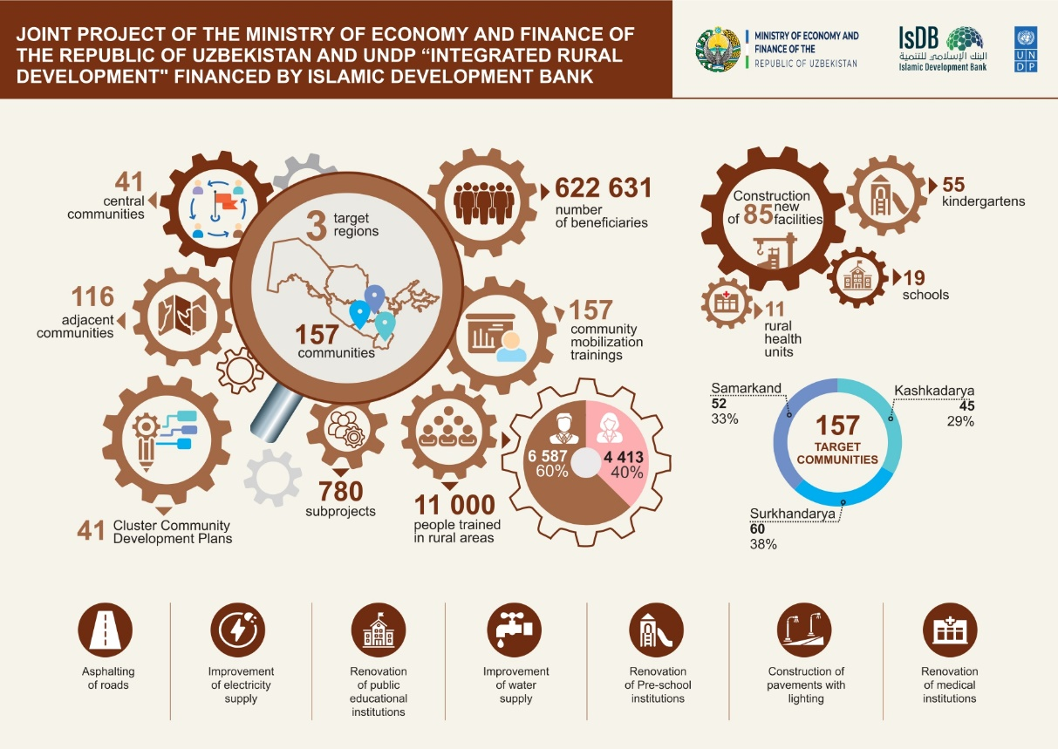

PROGRESS OF ACTIVITY 2:
Output 2: Capacity building in income generation, with focus on vulnerable groups. Outputs: Strengthened capacities of businesses and individuals such as entrepreneurs who work in agriculture complex, including the vulnerable groups in businesses development/expansion.
Activity 2.1 Regional market diagnostics/assessment of local business capacities
Progress:
- Procurement process of consulting company on conducting in-depth diagnostic assessments of supported regions specific business opportunities and applicability of agricultural climate smart solutions started.
Outputs:
- N/A

Activity 2.2 Design and delivery of targeted training on rural business development, with primary focus on the poor, women who are heads of households, young women and men and persons with disabilities. Training topics will be informed by regional market diagnostics. Vulnerable beneficiaries to be identified by communities. Trainings can be delivered in partnership with CSO.
Progress:
- Procurement process of consulting company on conducting training needs assessment started.
Outputs:
- N/A

Activity 2.3 Training of selected smallholder farmers on climate-smart solutions to increase agricultural productivity and inclusion into the value chain (e.g., water harvesting, drip irrigation, marketing) and crops diversification (e.g., fruit and nut trees).
Progress:
- N/A.
Outputs:
- N/A

Activity 2.4 Hands-on follow up technical support of farmers, businesses and individuals on inputs and technologies, sales, and marketing.
Progress:
- N/A
Outputs:
- N/A

Activity 2.5 Identification and promotion of locally relevant climate smart and energy efficient business solutions.
Progress:
- N/A
Outputs:
- N/A

PROGRESS OF ACTIVITY 3:
Capacity building of regional and local authorities.
Activity 3.1 Functional review of local authorities and communities (selected).
Progress:
- N/A
Outputs:
- N/A

Activity 3.2 Training of mahalla committees, women advisors and initiative groups in participatory planning, implementation, and M&E with a focus on women, youth, and vulnerable group
Progress:
- N/A
Outputs:
- N/A
Activity 3.3 Training of district khokimiyats, deputies on women’s issues, mahalla committees and women’s advisors, and initiative groups on climate change adaptation and mitigation.
Progress:
- N/A
Outputs:
- N/A
Activity 3.4 Implementation of participatory ICT solutions in integrated rural development planning, accountability, and sustainable management of infrastructure
Progress:
- N/A
Outputs:
- N/A
Activity 3.5 Training of local CSOs, women activists, women and vulnerable groups on effective engagement into regional and local decision-making. Some trainings can be delivered by CSOs.
Progress:
- N/A
Outputs:
- N/A
Activity 3.6 Training of district khokimiyats, deputies on women’s issues, mahalla committees and women’s advisors, initiative groups on maintenance schemes for all infrastructure and services created through CDPs, fostering environmentally and socially responsible approaches based on low costs and participatory, gender-responsive approaches.
Progress:
- N/A
Outputs:
- N/A

Activity 3.7 Number of effective practices in integrated rural development and advocacy identified for their scale-up regionally and nationally
Progress:
- N/A
Outputs:
- N/A

PROGRESS OF ACTIVITY 4:
Project Management
- Agreement and Project Document signed between Ministry of Economy and Finance and UNDP Uzbekistan on April 16, 2024, and came into force since May 13, 2024.
- Regional project office in process of established in Termez (Surkhandarya), Karshi (Kashkadarya) and in Samarkand (Samarkand)
- Annual Plan of Activities and budget ISDB Phase II for 2025 developed and approved by the Project Board
- IT Equipment, furniture and 3 project cars for ISDB Project Phase II procured
- UNDP staff recruitment is almost completed.
- Project launch event was organized on October 17, 2024
- 1st Project Board Meeting will be conducted on December 10, 2024

PROJECT RISKS
- Project offices establishment, project staff recruitment and procurement processes of IT equipment and projects cars would affect the on-time completion of the project activities planned for 2024 year.

CHALLENGES AND LESSONS LEARNED
- Challenges in engaging members of the Initiative Groups in volunteer project activities is linked to a lack of motivation among certain individuals
- Challenges in collecting necessary data about the community including the information about necessary infrastructure
- Challenges in engaging local authorities and working groups in making discussions of possible solutions
- Challenges in establishing collaborative work between community members and local authorities.
Annexes:
Annex 1. Project target reporting table of 2024 year
Annex 2. List of subprojects
Annex 3. List of publications
Annex 4. Donor Interim report
Annex 5. Request for 2nd installment

